Question 1:

As can be seen from the plots (1.1 in the appendix), Euler’s method gives the worst estimate for smaller x, but improves as x increases. RK4 gives a consistently close estimate for all x in the given range. RK4’s great advantage over Euler’s method is purely that here, Euler has a first order accuracy, as compared to RK4’s fourth order accuracy. Thus it’s expected that RK4 is that much better in approximating the actual solution, for all x in the given range.

Question 2:

Essentially, I started running the initial program from a stepsize of 0.4, then tabulated the value of E_{n} for both the Euler and RK4 methods in table 2.1. Then, I repeated this for h that were approximately half of the previous stepsize (about half I say, because I often rounded to ‘nicer’ values for the sake of brevity). This I kept doing until I got less than the required E_{n}.

Results:

For the Euler method, stepsize around 0.00025 required.
For RK4, stepsize around 0.05

Question 3:

Well, we know Euler’s method is of order 2, and RK4 is of order 5. This is a direct indication of their accuracy, as evident from the log-log graphs, 3.1 and 3.2. On comparison over the same intervals, we see the second graph has a much steeper gradient than the first, which is saying that as we decrease the order of magnitude of the stepsize, the RK4 method well approximates y(x) at 0.4 much more so than Euler.

Question 4:

The analytical solution is in the appendix.

Question 5:

Can very easily see from the tables 5.1 and 5.2 that for both values of p, the method used is very good at approximating the exact solution (taking the error at x=1 as an indication). However, it is also clear that the method is less accurate for larger values of p. Even an increase of 0.5 causes a noticeable change in how fast the error decays. This may be due to an increase in p causing an increase in oscillation frequency and sharpening of the exponential envelope curve on the actual solution. This may cause approximation difficulty as the rate of change of the curve would be steeper still as p is amplified.

Question 6:

Epsilon: 10⁻⁷ – The much slighter value here is used as of the need to compensate for the method of bisection, since this method halves intervals to find estimates, and some values in between the initial interval require more interval bisection to move close to (e.g. in [0,1], takes more steps to get as close to 0.01 than to 0.251). This can be compensated for by always taking a lot of steps, and this depends on epsilon only. So, I have decreased it accordingly.
Step-size: 10⁻³ – Here we have to balance accuracy (smaller values of h, decreasing error in RK4), against efficiency and runtime of the program (larger h, utilizing smaller arrays). However, I opted to use a somewhat larger value of stepsize (as compared to the epsilon), as RK4 is an order four method, hence can become very accurate for such step-sizes. Thus the program is both accurate and efficient in terms of runtime.

First eigenvalue estimate: 3.181132;
Second eigenvalue estimate: 6.303049;
Third eigenvalue estimate: 9.438030.
(Which are within the required tolerance.)

Question 7:

Plots are 7.1 through 7.3 in the appendix.

Looking at these plots, we see that in general, the n^{th} eigenvalue produces a curve with periodicity 2/n. This follows directly from the boundary conditions applied to the already periodic solutions of the differential equation. The next thing to be noted is that the first peak (from 0) decreases as p does, from 0.25 to 0.15 to 0.1 (approximately). This can be seen from the true solution as there is a factor O(p⁻¹). The last thing I want to point out is the exponential envelope on the curve; that is the exponential curves bounding the modulus of the approximation.
From a physical point of view, we are looking at a simple harmonic oscillator, with a damping term proportional to y’, and at the special cases where the system must return to the same state at ‘time’ unity. Then we see that the oscillation frequency is directly proportional to p, by looking at the undamped oscillations, thus relating to periodicity. The damping is unaffected by p, since we have introduced a forcing term independent of it. The exponential envelopes due to this are easily visible from the plots. Also, the fact that the curves attain lower initial amplitudes as the eigenvalues are increased is seen as a combination of the condition dy/dx(0)=1, and the fact that locally near 0, increasing p means increasing gradient (as frequency upped), thus the initial value of dy/dx, thus the amplitude must reduce as p is raised.

Appendix: Graph 1.1:
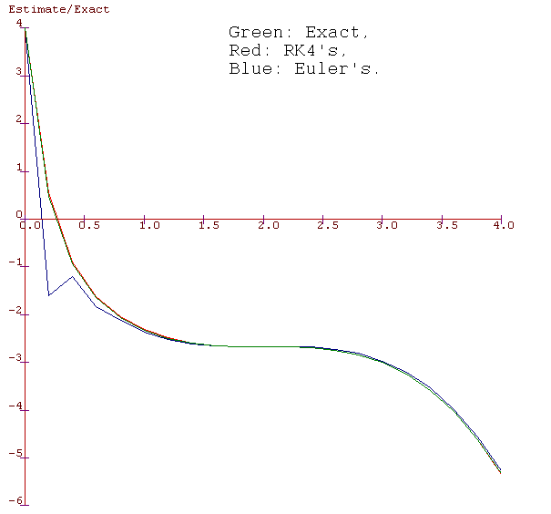
Table 2.1:
 | Absolute Error:
Stepsize, h |  | Euler's En: | RK4's En:
0.4 |  | 6.261538 | 1.957256
0.2 |  | 0.256738 | 0.045983
0.1 |  | 0.28845 | 0.000185
0.05 |  | 0.14583 | 0.000084
0.025 |  | 0.072526 | 0.000005
0.01 |  | 0.028861
0.005 |  | 0.014402
0.0025 |  | 0.007194
0.001 |  | 0.002876
0.0005 |  | 0.001437
0.00025 |  | 0.000719
(Note: halted finding En for the RK4 method, due to it being a higher order method, since after not many more reductions of h, the errors would fall out of the precision range.)

Graph 3.1:
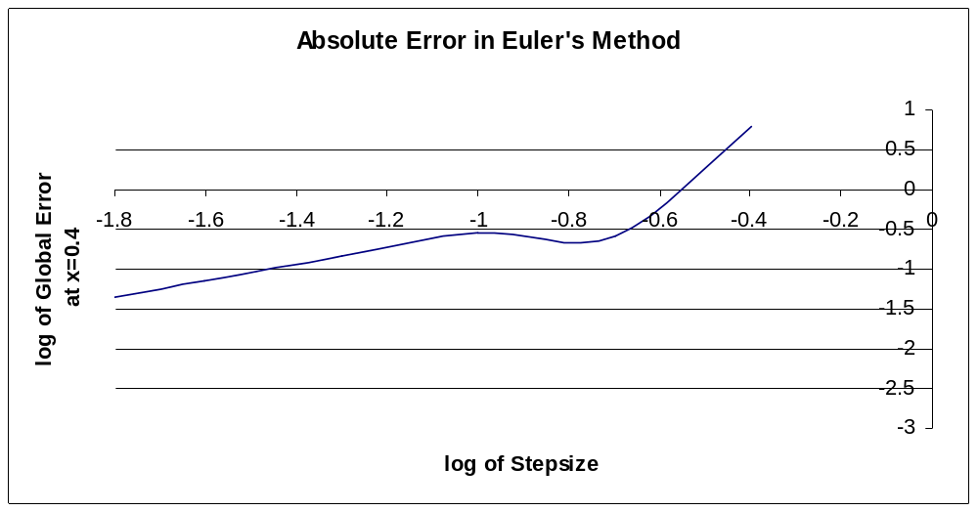
Graph 3.2:
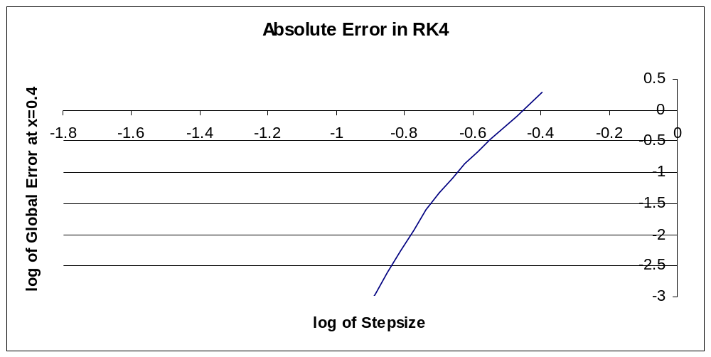
Table 5.1:
p=3:
Stepsize, h |  | Value of Yn | Error at x=1
0.5 |  | 0.062493 | 0.025068
0.25 |  | 0.039217 | 0.001791
0.1 |  | 0.037465 | 0.00004
0.05 |  | 0.037428 | 0.000002
Table 5.2:
p=3.5:
Stepsize, h |  | Value of Yn | Error at x=1
0.5 |  | -0.007292 | 0.048202
0.25 |  | -0.052351 | 0.003143
0.1 |  | -0.055436 | 0.000058
0.05 |  | -0.055491 | 0.000003

Plot 7.1:
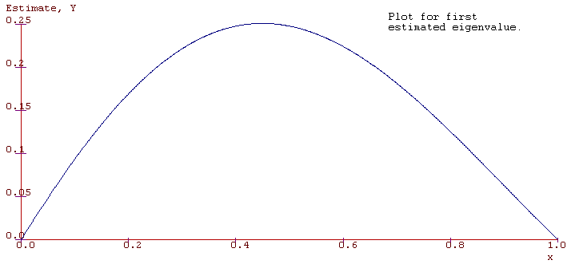
Plot 7.2:
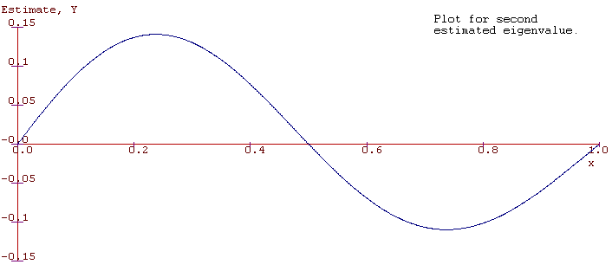
Plot 7.3:
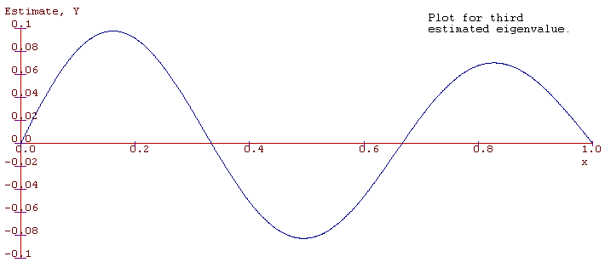
Project Listing:
1_1EulerRK4.c – Solves a specific ODE with Euler and RK4.
1_1SpecODERK4.c – Solves another specific ODE with RK4 only.
1_1Bisection.c – Bisection to find eigenvalues of an ODE with boundary conditions.

1_1EulerRK4.c:

#include <catam.h>
int opt;
double dydx(double x,double y) {
return -6*y-2*x*x*x+11*x*x-20*x-4;}
double k1,k2,k3,k4,h,x[2500],y[2500],t[2500],E[2500];
int i,n;
int MainCL(void) {

h= ReadDoubleCL("Enter step-size:",0.01);
n=ReadIntCL("Enter number of steps (<100):",50);
x[0]=0;
y[0]=4;

for (i=0;i<n;i++) {
x[i]=h*i;
t[i]=4*exp(-6*x[i])-x[i]*x[i]*x[i]/3+2*x[i]*x[i]-4*x[i];
}
do
{
printf("1: Use Euler's Method \n");
printf("2: Use RK4's Method \n");
printf("3: Plot <Exact> solution \n");
printf("4: Quit..");
printf("\nMake your choice:\n\n");
fflush(stdout);
scanf("%d",&opt);
switch(opt)
{
case 1:
printf("By Euler's Method:\n\n");
for (i=1;i<n;i++) {
y[i]=y[i-1]+h*dydx(x[i-1],y[i-1]);
E[i]=y[i]-t[i];
}

printf("x: y: Global Error:");
printf("\n");
for (i=0;i<n;i++) {
printf("%f %f %f\n",x[i],y[i],E[i]);}

PauseCL();
XRangeCL(0,4);
YRangeCL(-5,5);
YAxisLabelCL("Estimate/Exact");
XYCurveCL(x,y,n,1,JOIN,BlueCC,AUTOAXES);
break;
case 2:
printf("By Runge-Kutta's (4) Method:\n\n");
for (i=1;i<n;i++) {
k1=h*dydx(x[i-1],y[i-1]);
k2=h*dydx(x[i-1]+0.5*h,y[i-1]+0.5*k1);
k3=h*dydx(x[i-1]+0.5*h,y[i-1]+0.5*k2);
k4=h*dydx(x[i-1]+h,y[i-1]+k3);
y[i]=y[i-1]+(k1+2*k2+2*k3+k4)/6;
E[i]=y[i]-t[i];
}

printf("x: y: Global Error:");
printf("\n");
for (i=0;i<n;i++) {
printf("%f %f %f\n",x[i],y[i],E[i]);}

PauseCL();
XRangeCL(0,4);
YRangeCL(-5,5);
YAxisLabelCL("Estimate/Exact");
XYCurveCL(x,y,n,1,JOIN,RedCC,AUTOAXES);
break;
case 3:
XRangeCL(0,4);
YRangeCL(-5,5);
YAxisLabelCL("Estimate/Exact");
XYCurveCL(x,t,n,1,JOIN,GreenCC,AUTOAXES);
}
}
while(opt<4);
return 0;}

1_1SpecODERK4.c:

#include <catam.h>

double tiny=0.005;
double p,h,ky1,ky2,ky3,ky4,kz1,kz2,kz3,kz4,x[1000],y[1000],z[1000],t[1000],E[1000];
int i,n;

double dydx(double y,double z) {
return z;}
double dzdx(double y,double z) {
return -z-p*p*y;}

int MainCL(void) {
x[0]=0;
y[0]=0;
z[0]=1;

p=ReadDoubleCL("Enter value of p",1);
h=ReadDoubleCL("Enter step-size",0.01);
n=ReadIntCL("Enter number of steps",50);

for (i=1;i<n;i++) {
x[i]=i*h;
ky1=h*dydx(y[i-1],z[i-1]);
kz1=h*dzdx(y[i-1],z[i-1]);
ky2=h*dydx(y[i-1]+0.5*ky1,z[i-1]+0.5*kz1);
kz2=h*dzdx(y[i-1]+0.5*ky1,z[i-1]+0.5*kz1);
ky3=h*dydx(y[i-1]+0.5*ky2,z[i-1]+0.5*kz2);
kz3=h*dzdx(y[i-1]+0.5*ky2,z[i-1]+0.5*kz2);
ky4=h*dydx(y[i-1]+ky3,z[i-1]+kz3);
kz4=h*dzdx(y[i-1]+ky3,z[i-1]+kz3);
y[i]=y[i-1]+(ky1+2*ky2+2*ky3+ky4)/6;
z[i]=z[i-1]+(kz1+2*kz2+2*kz3+kz4)/6;
}

if (fabs(p)+tiny<0.5) {for (i=0;i<n;i++) {
t[i]=(2/sqrt(1-4*p*p))*exp(-0.5*x[i])*sinh(0.5*x[i]*sqrt(1-4*p*p));}}

if (fabs(p)-tiny>0.5) {for (i=0;i<n;i++) {
t[i]=(2/sqrt(4*p*p-1))*exp(-0.5*x[i])*sin(0.5*x[i]*sqrt(4*p*p-1));}}

if (fabs(p-0.5)<tiny) {for (i=0;i<n;i++) {t[i]=x[i]*exp(-0.5*x[i]);}}

for (i=0;i<n;i++) {E[i]=y[i]-t[i];}

printf("x: y: Global Error:");
printf("\n");
for (i=0;i<n;i++) {
printf("%f %f %f\n",x[i],y[i],E[i]);}

PauseCL();
XYCurveCL(x,y,n,1,JOIN,BlueCC,AUTOAXES);
return 0;
}

1_1Bisection.c:

#include <catam.h>

double a,b,m,pa,pb,phalf;
double p,h,e,ky1,ky2,ky3,ky4,kz1,kz2,kz3,kz4,x[1000000],y[1000000],z[1000000];
int i,n;
WindowCT w;

double dydx(double y,double z) {
return z;}
double dzdx(double y,double z) {
return -z-p*p*y;}

double xone(double h) {
n = (1/h)+1;
x[0]=0;
y[0]=0;
z[0]=1;
for (i=1;i<n+1;i++) {
x[i]=i*h;
ky1=h*dydx(y[i-1],z[i-1]);
kz1=h*dzdx(y[i-1],z[i-1]);
ky2=h*dydx(y[i-1]+0.5*ky1,z[i-1]+0.5*kz1);
kz2=h*dzdx(y[i-1]+0.5*ky1,z[i-1]+0.5*kz1);
ky3=h*dydx(y[i-1]+0.5*ky2,z[i-1]+0.5*kz2);
kz3=h*dzdx(y[i-1]+0.5*ky2,z[i-1]+0.5*kz2);
ky4=h*dydx(y[i-1]+ky3,z[i-1]+kz3);
kz4=h*dzdx(y[i-1]+ky3,z[i-1]+kz3);
y[i]=y[i-1]+(ky1+2*ky2+2*ky3+ky4)/6;
z[i]=z[i-1]+(kz1+2*kz2+2*kz3+kz4)/6;
}

return y[n];}

int MainCL(void) {
x[0]=0;
y[0]=0;
z[0]=1;

e=ReadDoubleCL("Epsilon:",0.0000001);
h=ReadDoubleCL("Step-size (dividing 1 naturally):",0.001);
PrintfCL(1,1,"Now, please enter the interval required to search in");
PrintfCL(1,2,"for an eigenvalue estimate.");
PrintfCL(1,3,"For the first, try (3,4);");
PrintfCL(1,4,"Second, try (6,7);");
PrintfCL(1,5,"Third, (9,10).");
PrintfCL(1,6,"And so on.");

a=ReadDoubleCL("Left side of interval:",3);
b=ReadDoubleCL("Right side of interval:",4);

do {

m=0.5*(a+b);
p=a;
pa=xone(h);
p=b;
pb=xone(h);
p=m;
phalf=xone(h);

if (pa>0) {if (phalf>0) {a=m;} else {b=m;}}
if (pa<0) {if (phalf>0) {b=m;} else {a=m;}}

} while (fabs(phalf)>e);

PrintfCL(1,7,"Eigenvalue estimate is %f.",m);

w = WindowCL(0.1,0.1,0.9,0.7);
WShowCL(w);
WTitleCL("Graph for approximated eigenvalue soln");
PauseCL();
XRangeCL(0,4);
YRangeCL(-5,5);
XAxisLabelCL("x");
YAxisLabelCL("Estimate, Y");
XYCurveCL(x,y,n+1,1,JOIN,BlueCC,AUTOAXES);

return 0;}

